**CloudWatch Project using SNS service**

Configuring alarm in CloudWatch using SNS service to receive mail notification once CPU utilization went above threshold.

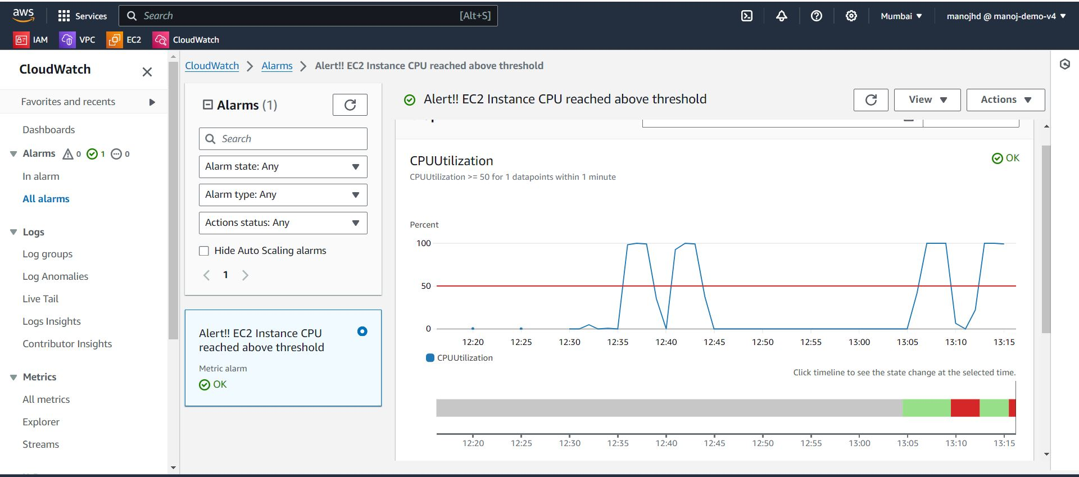

Running Python script to make CPU utilization high manually by creation EC2 instance.

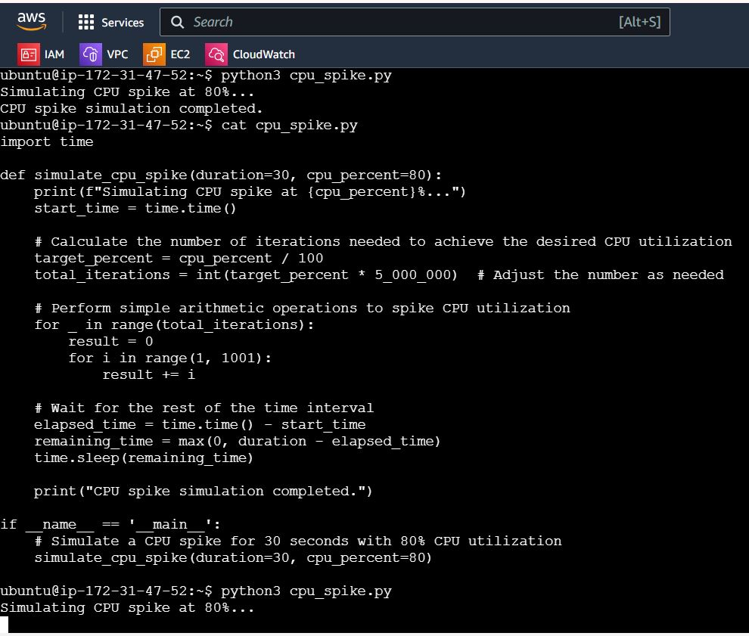

CPU utilization went above threshold post running script on EC2 instance.

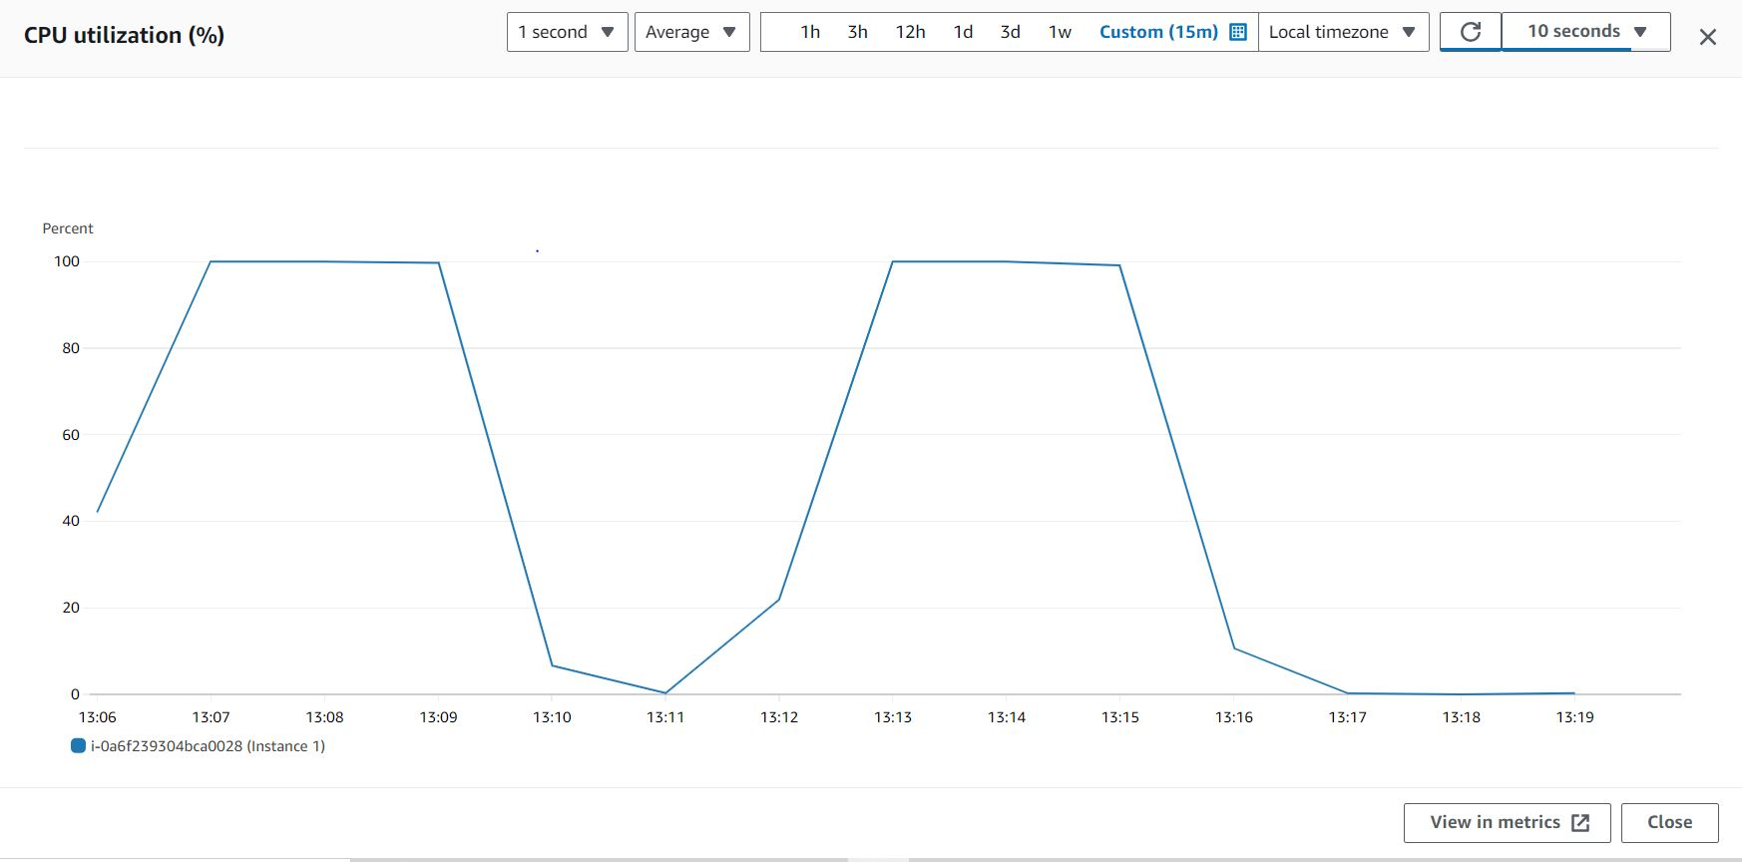

Received mail notification once CPU utilization crossed above limit.

